Power Automate
Flow Documentation
Automation Flows — Technical & Functional Overview
Prepared by: T Mohit Rao | Date: May 2026 | Version: 1.0

Table of Contents
Table of Contents
1. Objective of the Solution 2
2. Flow 1 — Pending_Actions_Reminders 3
2.1 Purpose & Schedule 3
2.2 Prerequisites 3
2.3 Working Logic 4
2.4 Key Features 4
2.5 Error Handling 4
2.6 Flow Screenshots 5
3. Flow 2 — Mail_Receive-Excel_Update 6
3.1 Purpose & Trigger 6
3.2 Working Logic 6
3.3 Smart Data Handling 7
3.4 Post-Update Actions 7
3.5 Exception & Error Handling 7
3.6 Flow Screenshots 8

1. Objective of the Solution

- Objective of the Solution

◆ | Automate Tracking: Automate the tracking and follow-up of pending actions, eliminating the need for manual monitoring and intervention.
◆ | Reduce Manual Effort: Significantly reduce manual effort in monitoring, updating, and communicating action statuses across teams.
◆ | Ensure Data Consistency: Maintain data integrity and consistency across all records by applying standardized input validation and normalization rules.
◆ | Timely Communication: Guarantee timely communication through automated reminders and notifications, ensuring stakeholders remain informed.
◆ | Operational Efficiency: Improve overall operational efficiency with robust error handling, proactive alerting, and intelligent exception management.

2. Flow 1 — Pending_Actions_Reminders

2.1 Purpose & Schedule

This is a scheduled automation flow designed to send daily reminders for all pending actions. It runs every weekday (Monday to Friday) at 10:20 AM, automatically skipping weekends. The flow reads from a structured Excel table, identifies overdue or in-progress actions, and dispatches consolidated reminder emails to the responsible owners.

Flow Name | Pending_Actions_Reminders
Type | Scheduled Cloud Flow
Schedule | Monday – Friday at 10:20 AM
Weekends | Excluded automatically
Data Source | Excel table stored in SharePoint / OneDrive
Notification | Consolidated email via Outlook

2.2 Prerequisites

● | Excel File Location: The Excel workbook must be stored in SharePoint or OneDrive and accessible to the flow connection account.
● | Formatted Table: Data must reside in a properly formatted Excel table with a defined, unique table name — not just a plain spreadsheet range.
● | RowID Column (Hidden): A hidden column named RowID must be present. It must contain a unique, static identifier for each row that does not change over time. This is critical for accurate row matching across operations.

2.3 Working Logic

Step | Action | Description
Step 1 | Trigger | Flow triggers at 10:20 AM on weekdays per the recurrence schedule.
Step 2 | Read Data | Reads all rows from the defined Excel table in SharePoint / OneDrive.
Step 3 | Apply Filters | Filters rows where Status = 'In Progress' OR 'Not Started', AND Month of Action ≤ current month or next month.
Step 4 | Extract Owners | Extracts Owner Email IDs from filtered rows; supports multiple owners in a single cell (separated by semicolons).
Step 5 | Group Actions | Groups all matching actions per owner into a single consolidated list to avoid duplicate emails.
Step 6 | Send Emails | Dispatches a single consolidated reminder email per owner via Outlook, listing all their pending actions.

2.4 Key Features

✓ | Handles large datasets efficiently without timeout or performance degradation.
✓ | Supports multiple owners in a single cell, separated by a semicolon ( ; ).
✓ | Ignores rows that have no assigned owner — no unnecessary processing.
✓ | Groups multiple pending actions per owner into a single consolidated email.

2.5 Error Handling

The flow implements a Try-Catch pattern to gracefully handle failures and ensure the support team is immediately notified of any issue.

Timeout Errors: Caught and logged; support team notified automatically.
Failed Run Steps: Failure scope triggers error notification with direct link to the failed run.
Skipped Steps: Tracked and reported to allow root-cause analysis.
Notification: Error alert emails are sent to the support team with a navigation link to the Power Automate run history.

2.6 Flow Screenshots

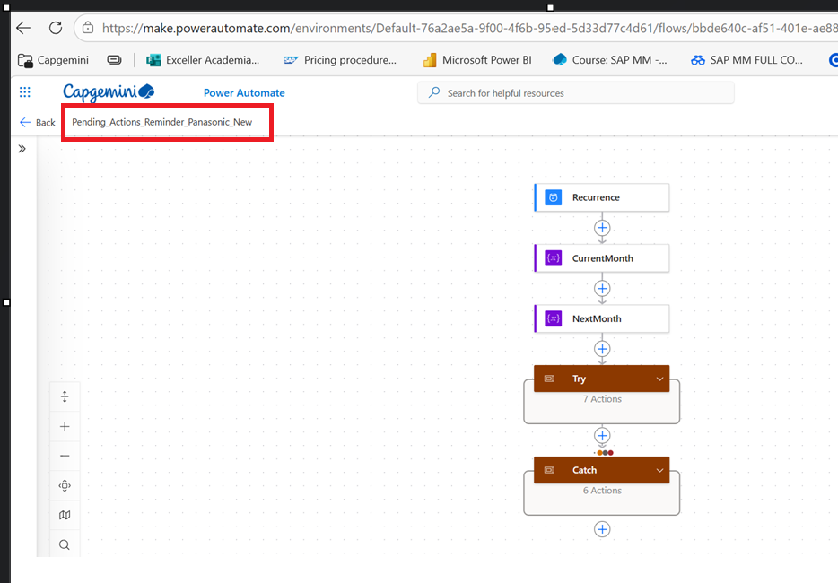
Fig 2.2 Pending_Action_Reminer_Flow

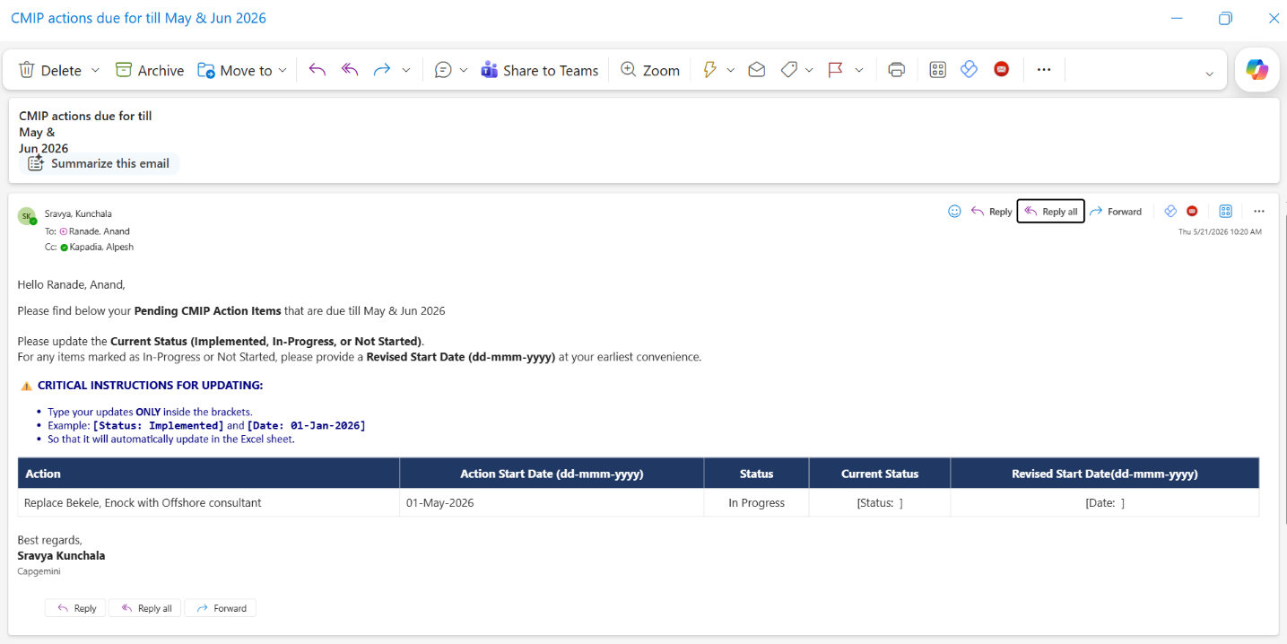
Fig 2.3 Outlook Mail

3. Flow 2 — Mail_Receive-Excel_Update

3.1 Purpose & Trigger

This flow automatically updates Excel records based on information received in structured incoming emails. It eliminates the need for manual data entry by parsing email body content and writing the extracted values directly back into the corresponding Excel rows.

Flow Name | Mail_Receive-Excel_Update
Type | Automated Cloud Flow (Email Triggered)
Trigger | Email received with subject containing: 'CMIP actions due'
Data Target | Excel table stored in SharePoint / OneDrive
Post-Action | Microsoft Teams notification to support team

3.2 Working Logic

Step | Action | Description
Step 1 | Email Trigger | Flow activates when an email with the subject keyword 'CMIP actions due' is received.
Step 2 | Extract Body | Extracts the full email body content for parsing.
Step 3 | Parse Placeholders | Identifies and extracts three key placeholders: [Status:], [Date:], and [RowId:](Hidden Column in the Mail).
Step 4 | Loop Records | Iterates through each extracted record within the email body.
Step 5 | Match RowId | Matches the extracted RowId against the Excel table to locate the exact row.
Step 6 | Update Fields | Updates the Status and Date fields in the matched Excel row.
Step 7 | Notify Team | Sends a Microsoft Teams notification to the support team confirming the successful update.

3.3 Smart Data Handling

Status Normalization
The flow standardizes all incoming status values to ensure consistency in the Excel table, regardless of how the user typed them:

Accepted Input Variants | Standardized Output
InProgress / In Progress / in-progress | - In Progress
Notstarted / Not Started / Not-Started | - Not Started
Implement / Implemented | - Implemented

Date Format Handling

★ | Preferred Format: | dd-MMM-yyyy (e.g., 01-May-2026)
■ | Also Accepted: | dd-mm-yyyy (e.g., 01-05-2026)

Additional Smart Behaviors

Ignores empty submissions — no updates are made if the email contains no valid data.
Validates status and date values before writing to Excel.
Handles partial submissions gracefully without corrupting existing records.

3.4 Post-Update Actions

Upon successful completion of all Excel updates, the flow sends an automated Microsoft Teams notification to the support team. This confirmation message includes details of the records updated, enabling the team to verify and audit all changes without needing to open the Excel file directly.

3.5 Exception & Error Handling

The flow uses Try-Catch implementation for comprehensive exception management, covering both validation failures and technical errors:

Scenario | Response
Invalid status value received | Teams’ notification sent to support team for manual review and correction
Date format parsing failure | Teams’ notification sent for manual date correction by support team
Timeout / flow run failure | Error caught by Try-Catch; detailed alert email with run link sent to support
Skipped steps detected | Logged and reported to support team for investigation

3.6 Flow Screenshots

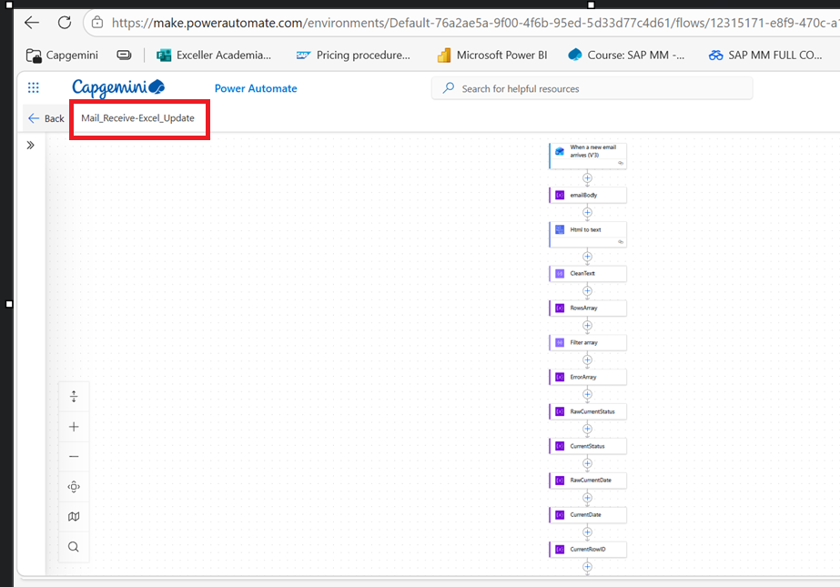

Fig 3.1 Mail_Receive-Excel_Update Flow

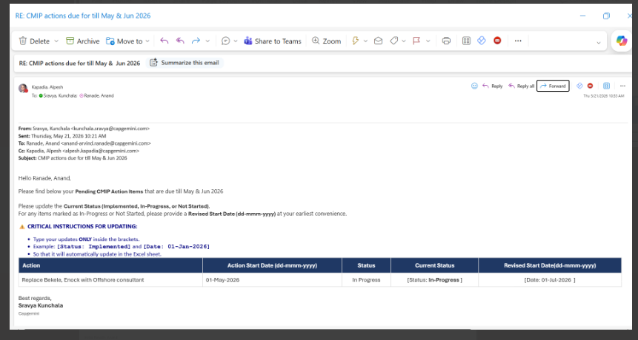

Fig 3.2 User updated the Status and Date and send back to us.

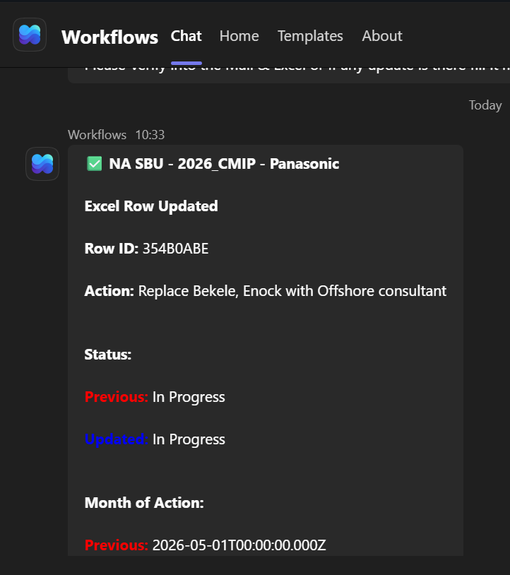

Fig 3.3 Teams Message once the Row is successfully updated on the Excel.

